**IAM users access the S3 bucket time-based**

STEPS:

* Create a new S3 bucket.

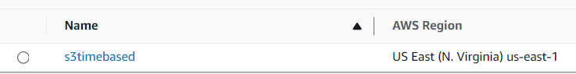

* Create an IAM user.

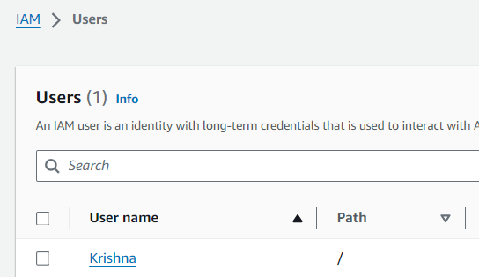

* In permissions tab > Add permissions > Create inline policy

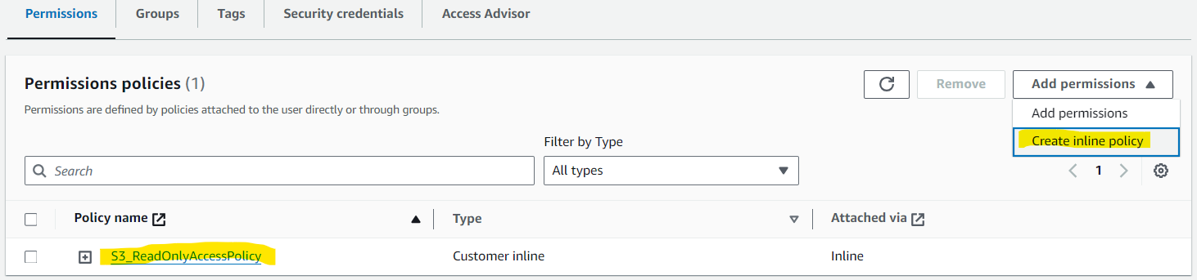

Add the JSON to below

{

"Version": "2012-10-17",

"Statement": [

{

"Effect": "Allow",

"Action": [

"s3:GetBucketLocation",

"s3:ListAllMyBuckets"

],

"Resource": "*"

},

{

"Effect": "Allow",

"Action": [

"s3:ListBucket",

"s3:ListBucketVersions",

"s3:PutBucketVersioning"

],

"Resource": [

"arn:aws:s3:::s3timebased"

]

},

{

"Effect": "Allow",

"Action": [

"s3:GetObject"

],

"Resource": [

"arn:aws:s3:::s3timebased/*"

]

},

{

"Effect": "Allow",

"Action": [

"s3:ListBucket",

"s3:ListBucketVersions",

"s3:PutBucketVersioning",

"s3:GetObject"

],

"Resource": [

"arn:aws:s3:::s3timebased/*"

],

"Condition": {

"DateGreaterThan": {

"aws:CurrentTime": "2024-04-28T00:00:00Z"

},

"DateLessThan": {

"aws:CurrentTime": "2024-04-28T01:00:00Z"

}

}

}

]

}